**UNLOCKING HR INSIGHTS**

*A Project Report Submitted in the partial fulfilment of the requirements for the award of the degree*

*of*

**BACHELOR OF TECHNOLOGY**

**IN**

**COMPUTER SCIENCE ENGINEERING (DATA SCIENCE)**

*By*

**YANAMALA MAHESH (21981A4463)**

**KOSANAM PREETHI KAREN (21981A4430)**

**PABBINA VINAY (21981A4446)**

**PAPPU BINDU (21981A4448)**

**UNDER THE ESTEEMED GUIDANCE OF**

**Mr. V. GOVINDA RAO**

**ASSISTANT PROFESSOR**

#### **DEPARTMENT OF COMPUTER SCIENCE AND ENGINEERING**

**RAGHU ENGINEERING COLLEGE**

**(AUTONOMOUS)**

**Affiliated to JNTU GURAJADA, VIZIANAGARAM**

**Approved by AICTE, Accredited by NBA, Accredited by NAAC with A+ grade**

[www.raghuenggcollege.com](http://www.raghuenggcollege.com)

**2024-2025**

### **RAGHU ENGINEERING COLLEGE**

**(AUTONOMOUS)**

**Affiliated to JNTU GURAJADA, VIZIANAGARAM**

**Approved by AICTE, Accredited by NBA, Accredited by NAAC with A+ grade**

[www.raghuenggcollege.com](http://www.raghuenggcollege.com)

 **2024-2025**

#### **DEPARTMENT OF COMPUTER SCIENCE AND ENGINEERING (DATA SCIENCE)**

**CERTIFICATE**

This is to certify that this project entitled “**UNLOCKING HR INSIGHTS**” done by “**Y. Mahesh (RollNo.21981A4463), K. Preethi Karen (RollNo.21981A4430), P. Vinay (21981A4446), P. Bindu (21981A4448)** ” are students of B.Tech in the Department of Computer Science and Engineering (Data Science), Raghu Engineering College, during the period 2024-2025, in partial fulfilment for the award of the Degree of Bachelor of Technology in Computer Science and Engineering(Data Science) to the Jawaharlal Nehru Technological University, Gurajada, Vizianagaram is a record of bonafide work carried out under my guidance and supervision.

The results embodied in this project report have not been submitted to any other University or Institute for the award of any Degree.

**Internal Guide Head of the Department**

**Guide Name Dr.K.V.Satyanarayana**

**Dept of CSE(Data Science), Dept of CSE(Data Science),**

**Raghu Engineering College, Raghu Engineering College, Dakamarri (V), Dakamarri (V),**

**Visakhapatnam Visakhapatnam**

**EXTERNAL EXAMINER**

## DISSERTATION APPROVAL SHEET

*This is to certify that the dissertation titled*

#### **UNLOCKING HR INSIGHTS**

***BY***

**YANAMALA MAHESH (21981A4463)**

**KOSANAM PREETHI KAREN (21981A4430)**

**PABBINA VINAY (21981A4446)**

**PAPPU BINDU (21981A4448)**

*Is approved for the degree of* ***Bachelor of Technology***

**Mr. V. Govinda Rao**

**Assistant Professor**

Internal Examiner

**External Examiner**

**Dr. K. V. Satyanarayana**

**HOD**

Date:

## DECLARATION

This is to certify that this project titled “**UNLOCKING HR INSIGHTS**” is bonafide work done by us, in partial fulfilment of the requirements for the award of the degree B.Tech and submitted to the **Department of Computer Science and Engineering (Data Science), Raghu Engineering College, Dakamarri.**

We also declare that this project is a result of our effort and that has not been copied from anyone and we have taken only citations from the sources which are mentioned in the references. This work was not submitted earlier at any other University or Institute for the reward of any degree.

**YANAMALA M****AHESH KOSANAM. PREETHI KAREN**

**(21981A4463) (21981A4430)**

**PABBINA. VINAY PAPPU. BINDU**

**(21981A4446) (21981A4448)**

**Date:**

**Place:**

## ACKNOWLEDGEMENT

We express our sincere gratitude to my esteemed Institute “Raghu Engineering College”, which has provided us with an opportunity to fulfil the most cherished desire to reach my goal.

We take this opportunity with great pleasure to put on record our ineffable personal indebtedness to **Sri Raghu Kalidindi,** Chairman of Raghu Engineering College (A)for providing necessary departmental facilities.

We would like to thank the Principal **Dr. Ch. Srinivasu, Dr A.Vijay Kumar** - Dean planning & Development, **Dr E.V.V.Ramanamurthy**-Controller of Examinations, and the Management of **“**Raghu Engineering College”, for providing the requisite facilities to carry them out the project in the campus.

Our sincere thanks to **Dr. R. Sivaranjini ,**  Dean, Department of Computer Science and Engineering, Raghu Engineering College, for this kind support in the successful completion of this work.

Our sincere thanks to **Dr.S.Srinadh Raju**, Department of Computer Science and Engineering(Data Science), Raghu Engineering College, for this kind support in the successful completion of this work.

Our sincere thanks to **Dr. K. V. Satyanarayana ,** Program Head, Department of Computer Science and Engineering(Data Science), Raghu Engineering College, for this kind support in the successful completion of this work.

We sincerely express our deep sense of gratitude to **Mr. V. Govinda Rao,** Assistant Professor**,** Department of Computer Science and Engineering(Data Science), Raghu Engineering College(A), for his perspicacity, wisdom, and sagacity coupled with compassion and patience. It is our great pleasure to submit this work under his wing.

We extend deep-hearted thanks to all faculty members of the Computer Science department(Data Science), for the value-based imparting of theory and practical subjects, which were used in the project.

We are thankful to the non-teaching staff of the Department of Computer Science and Engineering, Raghu Engineering College for their inexpressible support.

We thank all those who contributed directly or indirectly in successfully carrying out this project work.

**Regards**

**Y.Mahesh (21981A4463)**

**K. Preethi Karen (21981A4430)**

**P. Vinay (21981A4446)**

**P. Bindu (21981A4448)**

## ABSTRACT

Human Resource (HR) data analytics is a rapidly growing field that leverages data-driven insights to optimize workforce management and decision-making. This project addresses the critical need for data-driven decision-making in Human Resources by developing an interactive Power BI dashboard to analyze employee attendance patterns. Leveraging publicly available real-world datasets, specifically attendance sheets from different platforms, this initiative aims to empower HR Generalists with actionable insights regarding employee retention, sick leave trends, work from home (WFH) and work from office (WFO).

The methodology encompasses a comprehensive data lifecycle, starting with data collection and meticulous transformation using Power Query to consolidate and restructure attendance data for effective analysis. DAX (Data Analysis Expressions) is employed to create dynamic measures, enabling a granular understanding of attendance dynamics. The resulting Power BI dashboard provides interactive visualizations. This project demonstrates the application of HR analytics to improve workforce management by providing a robust framework for continuous updates and enhancements. The dashboard enables HR professionals to strategically plan key events, implement targeted retention strategies, and address factors contributing to sick leave percentages. By quantifying and visualizing attendance data, this project provides a foundation for enhancing employee satisfaction, well-being, and overall organizational effectiveness.

**Keywords**: HR analytics, Data- driven decision making, WFH, WFO, DAX, Dashboard.

|  |  |
| --- | --- |
| **INDEX** |  |
| **CONTENT** | **PAGE NUMBER** |
| Certificate | ii |
| Dissertation Approval Sheet | iii |
| Declaration | iv |
| Acknowledgement | v |
| Abstract | vi |
| Contents | vii |
| List of Figures | viii |
| **1. INTRODUCTION** |  |
| 1.1 Purpose | 2 |
| 1.2 Scope | 3 |
| * 1. Motivation   2. Proposed Algorithm | 3  4 |
| 1.5 Work Flow of Proposed System | 5 |
| **2. LITERATURE SURVEY** |  |
| 2.1 Introduction to Literature Survey | 7 |
| 2.2 Literature Surve | 8 |
| 1. **SYSTEM ANALYSIS**    1. Introduction | 11 |
| 3.2 Problem Statement | 12 |
| 3.3 Existing System | 13 |
| 3.4 Proposed System | 15 |
| 3.5 Feasibility | 16 |
| 1. **SYSTEM REQUIRMENTS**    1. Software Requirements | 18 |
| 4.2 Hardware Requirement | 18 |
| 4.3 Project Perquisites | 19 |

|  |  |
| --- | --- |
| **5. SYSTEM DESIGN** |  |
| 5.1 Introduction | 21 |
| 5.2 System Model | 21 |
| 5.3 System Architecture | 21 |
| 5.4 UML Diagrams | 22 |
| 5.5 User case diagram | 24 |
| 5.6 Class Diagram | 25 |
| 5.7 Sequential Diagram | 26 |
| 5.8 Collaboration Diagram | 27 |
| **6. IMPLEMENTATION** |  |
| 6.1 Technology Description | 29 |
| 6.2 Techniques Used | 30 |
| 6.3 Source Code | 32 |
| 6.3.1 DAX Code | 33 |
| **7. TESTING** |  |
| 7.1 Introduction to Testing | 35 |
| 7.2 Types of testing | 36 |
| 7.3 Test Cases | 37 |
| **8. RESULTS & DISCUSSIONS** | 39 |
| **9. CONCLUSION AND FUTURE ENHANCEMENTS** | 42 |
| **10. REFRENCES** | 45 |
| **11. PAPER PUBLICTION** |  |
| **12. INTERNSHIP CERTIFICATES** |  |

**LIST OF FIGURES**

|  |  |
| --- | --- |
| **Figure** | **Page Number** |
| Figure 1.5 Work Flow System | 5 |
| Figure 5.1 Data Flow System | 21 |
| Figure 5.2 UML Diagram | 22 |
| Figure 5.3 User case Diagram | 24 |
| Figure 5.4 Class Diagram | 25 |
| Figure 5.5 Sequential Diagram | 26 |
| Figure 5.6 Collaboration Diagram | 27 |
| Figure 8.1 Final Output | 39 |

# CHAPTER-1 INTRODUCTION

## INTRODUCTION

### Purpose

In today’s competitive business landscape, Human Resources (HR) departments are increasingly tasked with strategic decision-making that directly impacts organizational performance. Traditional, intuition-based approaches are being superseded by data-driven methodologies, enabling HR professionals to gain deeper insights into workforce dynamics and optimize human capital management. This project, "Unlocking HR Insights," aims to leverage the power of data analytics to transform raw employee attendance data into actionable intelligence, specifically focusing on patterns, trends, and key performance indicators related to attendance.

The primary purpose of this project is to develop an interactive and insightful Power BI dashboard that enables HR Generalists to effectively analyze employee attendance data. By visualizing key metrics such as present percentages, sick leave rates, and WFH/WFO distributions, the project aims to equip HR with the tools necessary to:

* **Identify and understand employee attendance patterns:** Uncover trends related to absenteeism, punctuality, and work location preferences.
* **Develop targeted retention strategies:** Identify potential areas of concern related to employee engagement and well-being, informing interventions to improve retention.
* **Analyze sick leave trends:** Understand the factors contributing to sick leave rates and implement strategies to promote employee health and well-being.
* **Optimize workforce management:** Gain insights into the balance between WFH and WFO arrangements to enhance productivity and employee satisfaction.
* **Facilitate strategic planning:** Provide data-driven insights to inform you about the scheduling and rescheduling of key organizational events.

This project demonstrates the application of HR analytics to improve workforce management by providing a robust framework for continuous updates and enhancements. The dashboard enables HR professionals to strategically plan key events, implement targeted retention strategies, and address factors contributing to sick leave percentages. By quantifying and visualizing attendance data, this project provides a foundation for enhancing employee satisfaction, well-being, and overall organizational effectiveness.

### Scope

The scope of this project is focused on the analysis of employee attendance data collected over a three-month period, encompassing key metrics such as present days, sick leaves, and the distribution of Work From Home (WFH) and Work From Office (WFO) arrangements. By utilizing publicly available real-world datasets, this project aims to demonstrate the practical application of HR analytics in a real-world scenario. The analysis will delve into identifying trends and anomalies in attendance patterns, determining the underlying reasons for fluctuations in sick leave percentages, and providing a clear understanding of the balance between WFH and WFO arrangements. The project will also facilitate the strategic planning and scheduling of key organizational events based on derived insights, ensuring alignment with workforce availability and productivity. The project will primarily focus on the data transformation and reporting of the attendance data provided and will not include predictive modelling or external data integration.

### Motivation

The driving force behind this project is the compelling realization that HR analytics has evolved from a supplementary function to a vital strategic asset for organizational achievement. In an era where data reigns supreme, the ability to convert raw, disparate data into actionable intelligence empowers HR professionals to transcend reactive measures and proactively shape a thriving work environment. Through this analytical lens, informed decisions can be made that directly cultivate employee satisfaction, effectively mitigate attrition, and ultimately, amplify overall productivity. This initiative is further fueled by a pressing need to break free from the constraints of static, traditional HR reporting, instead embracing the fluidity and interactivity of dynamic data visualization. It champions the empowerment of HR Generalists, equipping them with the tools and knowledge to independently dissect and interpret complex attendance data, fostering a culture of data literacy and self-sufficiency. Moreover, this project serves as a practical demonstration of the transformative potential of Power BI and DAX, showcasing their capacity to address tangible, real-world HR challenges. In a landscape increasingly defined by the demand for work location flexibility, such as Work From Home (WFH) and Work From Office (WFO) arrangements, this project addresses the imperative to comprehensively understand and effectively manage these evolving work paradigms, ensuring organizational agility and adaptability.

### Proposed Algorithm

A The proposed system leverages a multi-faceted approach, employing a combination of data transformation, statistical analysis, and visualization techniques.

The initial stage involves meticulous data collection and transformation using Power Query in Power BI, ensuring that the raw attendance data is cleaned, consolidated, and structured for effective analysis. This process includes data reshaping, combining datasets, and applying necessary transformations to create a unified and consistent dataset.

Subsequently, Data Analysis Expressions (DAX) will be utilized to create dynamic measures, including total working days, WFH and sick leave counts, present days, and corresponding percentages. These measures will enable a granular understanding of attendance dynamics and facilitate the identification of key trends and patterns.

The project will employ statistical operations to derive meaningful metrics and create calculated columns to enhance the analytical capabilities of the dashboard. Finally, the project will culminate in the development of an interactive Power BI dashboard, incorporating various visualization techniques such as card visuals, date slicers, employee data tables, and trend charts.

These visualizations will provide a clear and intuitive representation of the analyzed data, enabling HR professionals to quickly identify key insights and make data-driven decisions. The chosen algorithms and techniques are selected to provide a robust and adaptable framework for continuous updates and enhancements to the HR analytics process, ensuring that the insights derived remain relevant and actionable over time.

#### 

#### Work Flow of Proposed System

*Figure 1.5 Work Flow System*

# CHAPTER-2 LITERATURE SURVEY

## LITERATURE SURVEY

### Introduction to Literature Survey

The literature survey for the “Unlocking HR Insights” project explores existing research on HR analytics focusing on data-driven decision making in workforce management. Studies by researchers like Ansho Kuriakose, Dr, Abdul Quddus Mohammed, and Delfi Kurnia Zebua highlight the use of predictive analytics, statistical modelling, and machine learning in HR processes. Key areas of interest include employee attendance analysis, retention strategies, work-from-home trends, and churn prediction. BY leveraging these methodologies, our project builds a power BI dashboard to provide actionable insights into attendance patterns and workforce planning, enabling HR professionals to make decisions.

### Literature Survey

**AUTHORS: Ansho Kuriakose**

**TITLE: "** **HR Analytics - Empowering Organizations"**

**DESCRIPTION:** This study explores the transformative role of HR analytics in modern organizations, focusing on predictive data analytics. By analyzing employee performance, hiring trends, and retention patterns, HR analytics help businesses make informed decisions. The paper highlights how HR data, when combined with machine learning algorithms, can identify workforce productivity trends and enhance organizational efficiency. The study also discusses the ethical implications of using HR analytics and its potential to revolutionize talent management

**AUTHORS: Dr. Abdul Quddus Mohammed**

**TITLE: "** **HR Analytics: A Modern Tool in HR"**

**DESCRIPTION:** This paper provides an in-depth analysis of the integration of statistical data analysis, machine learning, and data mining techniques in HR practices. It emphasizes how HR analytics can be used for employee engagement, performance evaluation, and workforce planning. The research presents case studies showcasing companies that have successfully implemented HR analytics to optimize their recruitment process and reduce attrition rates. Additionally, it discusses how HR analytics can improve diversity and inclusion within organizations by eliminating biases in hiring and promotions.

**AUTHORS: Samuel Bangura**

**TITLE: "** **Effects of HR Analytics on HRM Practices"**

**DESCRIPTION:** This study adopts an integrative literature review approach to examine the impact of HR analytics on human resource management (HRM) practices. The paper explores how data-driven decision-making can enhance talent acquisition, employee retention, and workforce productivity. It also examines challenges organizations face when integrating HR analytics, such as data privacy concerns and the need for skilled HR professionals who can interpret analytical findings. The study suggests best practices for leveraging HR analytics to drive strategic HRM initiatives.

**AUTHORS: Delfi Kurnia Zebua**

**TITLE: "** **The Role of HR Analytics in Enhancing Organizational Performance"**

**DESCRIPTION:** This paper focuses on the application of predictive modeling and machine learning in HR analytics. The study demonstrates how organizations can use predictive analytics to anticipate employee needs, improve workforce planning, and enhance overall organizational performance. Through various case studies, the research highlights how data-driven HR strategies have resulted in better employee satisfaction, reduced turnover rates, and improved business outcomes. It also discusses the challenges organizations face in implementing HR analytics and the solutions to overcome them.

**AUTHORS: Jessien Law Jia Xin, Nomahaza Mahadi**

**TITLE: "** **HR Analytics for Data-Driven Employee Attrition Management"**

**DESCRIPTION:** This study employs a comprehensive approach, utilizing descriptive, diagnostic, predictive, and prescriptive analytics to address employee attrition challenges. It explores how organizations can identify high-risk employees prone to leaving and implement targeted retention strategies. The research provides insights into the factors influencing attrition, such as job satisfaction, compensation, and balance of work. It also presents recommendations for HR managers to use data analytics for designing personalized engagement programs that improve employee loyalty and reduce turnover rates.

**AUTHORS: Neeraj Khadilkar, Deepali Joshi**

**TITLE: "** **Predictive Modelling on Employability of Applicants and Job-Hopping"**

**DESCRIPTION:** This research examines the use of machine learning techniques in predicting job applicants' employability and the likelihood of job-hopping. By analyzing resumes, job history, and skill sets, predictive modeling helps HR managers make data-driven hiring decisions. The paper discusses how AI-driven hiring tools can match candidates with

the right job roles based on historical employment data. It also highlights the implications of job-hopping patterns on organizational stability and how companies can design policies to retain high-potential employees.

**AUTHORS: Aniket Tambde, Dilip Motwani**

**TITLE: "** **Employee Churn Rate Prediction and Performance"**

**DESCRIPTION:** This paper discusses the application of machine learning techniques in predicting employee churn rates. It presents an analytical framework that helps HR managers identify patterns associated with voluntary and involuntary turnover. The study highlights the impact of factors such as salary competitiveness, work culture, and career advancement opportunities on employee retention. It also explores how predictive analytics can be used to develop proactive retention strategies, such as personalized career development plans and targeted engagement programs.

# CHAPTER-3 SYSTEM ANALYSIS

## SYSTEM ANALYSIS

### Introduction

The system analysis for the "Unlocking HR Insights" project involves a detailed examination of the proposed data analytics dashboard, its design, key components, and underlying functionalities. This comprehensive phase aims to elucidate the system's architecture, analytical methodologies, and the integration of various data processing techniques, including data transformation in Power Query and DAX calculations. By dissecting the structure and mechanisms of this system, this analysis seeks to explain how it functions and how it addresses the challenges related to analyzing employee attendance and leave patterns.

### Problem Statement

The primary objective is to develop a robust data analytics dashboard that empowers HR professionals to gain actionable insights from employee attendance data. Through the analysis of attendance patterns, work-from-home (WFH) percentages, and sick leave (SL) trends, the study aims to provide data-driven strategies for improving employee retention, optimizing workforce management, and enhancing overall employee well-being. By leveraging Power BI's capabilities for data transformation and visualization, the project seeks to contribute to the development of efficient HR analytics systems that facilitate informed decision-making in human resource management.

### Existing System

The existing system revolves around **Human Resource Analytics (HR Analytics)**, which has emerged as a critical discipline within Human Resource Management (HRM). HR Analytics leverages data analysis to enhance decision-making processes related to human resources, thereby contributing to organizational performance and competitive advantage. The system emphasizes the strategic value of HRM by utilizing advanced statistical tools and methodologies to evaluate HR data. It aims to answer key HR questions, improve employee performance, forecast workforce requirements, and link HR practices to business outcomes. The process of HR Analytics typically involves defining objectives, collecting relevant data, assessing HR metrics, analyzing the data, and making informed decisions based on the insights derived.

#### Dis advantages :

1. **Limited Real-Time Insights**: The existing system do not provide real-time analytics or dynamic dashboards, which are crucial for timely decision-making. Your project emphasizes the use of Power BI for real-time data visualization and insights.
2. **Static Reporting**: Traditional HR analytics often relies on static reports that may not be updated frequently. Simple dashboards may not provide in-depth insights into attendance patterns, reasons for leave, or WFH/WFO trends.
3. **Lack of Predictive and Prescriptive Analytics**: The existing system may focus primarily on descriptive analytics, while your project incorporates predictive and prescriptive analytics to forecast trends and recommend actions.
4. **Manual Data Handling:**The existing system may require significant manual data entry and processing, leading to potential errors. Your project emphasizes automation in data transformation and cleaning using Power Query.
5. **Limited Employee Engagement:** Existing systems do not engage employees in the attendance tracking process and features that allow employees to view their attendance metrics, fostering accountability.
6. **Poor User Experience:** Traditional HR systems have outdated user interfaces that are not user-friendly and do not have create intuitive and visually appealing dashboards that enhance user experience.

#### Algorithms used in Existing :

1. Descriptive Analytics Algorithm

Random Utilizes basic statistical techniques (mean, median, variance) to describe historical data and answer questions about "what happened?" or "what is happening?"

* **Statistical Measures:** Algorithms that calculate mean, median, mode, variance,

and standard deviation to summarize historical data.

* **Data Visualization Techniques:** Tools like histograms, bar charts, and pie charts to visually represent data distributions and trends.

#### Dis Advantages :

1. **Limited Insight:** It focuses on historical data and does not provide insights into future trends or causal relationships. This limits the ability to make proactive decisions.
2. **Data Overload:** The sheer volume of data can lead to information overload, making it difficult for HR professionals to extract meaningful insights without advanced analytical skills.
3. Predictive Analytics Algorithm

Predictive analytics Applies advanced statistical methods (regression analysis, correlation analysis) to identify predictive variables and build models that forecast future trends and relationships. This answers questions like "what will happen?" or "why will it happen?"

* **Regression Analysis:** Linear and logistic regression models to identify relation

nships between variables and predict future outcomes based on historical data.

* **Time Series Analysis:** Algorithms that analyze data points collected or recorded at specific time intervals to forecast future trends (e.g., ARIMA models).
* **Classification Algorithms**: Techniques such as decision trees, random forests, and support vector machines (SVM) to categorize data into predefined classes (e.g., predicting employee attrition).

#### Dis Advantages :

1. **Assumption Dependence:** Many predictive models rely on assumptions about data distributions and relationships that may not hold true in real-world scenarios, leading to inaccurate predictions.
2. **Complexity:** Advanced predictive models (e.g., neural networks) can be complex and require specialized knowledge to implement and interpret, which may not be readily available in HR departments.
3. Prescriptive Analytics Algorithm

Prescriptive analytics Involves decision-making science and management methodologies to recommend actions based on data analysis. This answers questions like "what should be done?" or "why should it be done?"

* **Optimization Algorithms:** Techniques like linear programming and genetic alg

orithms to recommend the best course of action based on constraints and

objectives.

* **Simulation Models:** Monte Carlo simulations to assess the impact of risk and uncertainty in decision-making processes.

#### Dis Advantages :

1. **Resource Intensive:**Optimization algorithms can be computationally intensive and may require significant processing power and time, especially with large datasets.
2. **Overfitting:** Prescriptive models may overfit the data, meaning they perform well on historical data but poorly on new, unseen data, leading to suboptimal decision-makin

### PROPOSED SYSTEM

System The proposed system involves the development of a data analytics dashboard using Power BI to automate the analysis of employee attendance and leave data. By leveraging Power Query for data transformation and DAX for calculations, the system aims to provide HR professionals with real-time insights and actionable metrics. The dashboard will visualize key performance indicators (KPIs) such as present percentage, WFH percentage, and sick leave percentage, enabling data-driven decision-making. There are several Advantages :

* + - **Automated Data Processing:** Eliminates manual data entry and reduces the risk of errors.
    - **Advanced Analytics:** Leverages Power BI's capabilities for complex data analysis and calculations.
    - **Real-Time Insights:** Provides up-to-date information for timely decision-making.
    - **Interactive Visualizations:** Offers dynamic dashboards that enable users to explore data and identify trends.
    - **Scalability:** Can handle large volumes of data and is scalable for growing organizations.

### FEASIBILITY STUDY

This feasibility study assesses the viability of developing and implementing a Power BI attendance dashboard for Organization . It examines the technical, economic, operational, and schedule-related aspects of the project to determine its feasibility and potential benefits. Effective attendance tracking and analysis are crucial for Organization to monitor employee productivity, manage workforce resources, ensure compliance, etc. Currently, attendance data is managed through manual spreadsheets, time clocks, etc. which is time-consuming, error-prone, lacks reporting capabilities, etc. This project aims to develop a Power BI dashboard to automate attendance tracking, provide insightful reports, and improve overall attendance management.

|  |  |
| --- | --- |
|  | TECHNICAL FEASIBILITY |
|  | ECONOMIC FEASIBILITY |
|  | OPERATIONAL FEASIBILITY |

#### Economic Feasibility

* + **Cost Analysis**
  + Hardware requirements (e.g., Computer/Laptop)
  + Software development and integration
  + Maintenance and support
  + **Potential Cost Savings**
  + Improved accessibility and inclusivity leading to broader user base
  + Reduced need for specialized input devices
  + Potential for commercialization and revenue generation

#### Technical Feasibility

* + **Hardware Requirements**
  + Power BI is a readily available and widely used business intelligence platform.
  + Attendance data is currently stored Excel spreadsheets.
  + The data can be extracted and imported into Power BI.
  + The necessary skills in Power BI development, DAX, data modeling, and dashboard design.
  + Power BI offers scalability to accommodate future growth in data volume and user base.

#### Operational Feasibility

* The dashboard is designed to be user-friendly and intuitive.
* Training will be provided to users to ensure they can effectively use the dashboard.
* Promoting digital accessibility and inclusion within the media industry This feasibility study structure covers the key aspects that need to be evaluated to determine the viability and potential success of the proposed ASL-based.
* A detailed implementation plan will be developed, outlining the steps involved in deploying the dashboard, including data migration, user training, and ongoing maintenance.
* The implementation of the dashboard will be having attendance tracking process, eliminate manual reporting.

# CHAPTER-4 SYSTEM REQUIREMENTS

## SYSTEM REQUIREMENTS

### Software Requirements

* + - Operating System: Windows 8.1 or above
    - Power BI desktop: The latest version
    - Microsoft Office: Microsoft Office 2010 or above.

### Hardware Requirements

* + - Processor: 2GHz (x64) Processor or better
    - RAM: 8GB or more
    - Keyboard : Standandard Windows Keyboard
    - Mouse : Two/Three button mouse

Apart from these additional components like internet connectivity, camera or storage devices,an image display device, and a computer of a server are required.

.

### Project Perquisites

To successfully execute and derive meaningful insights from the attendance dashboard project, several prerequisites must be established.

* Firstly, a clear understanding of the project's objectives and scope is essential. This includes defining the specific metrics to be tracked, such as present percentage, work-from-home percentage, and sick leave percentage, as seen in the provided dashboard snapshot.
* A well-defined scope ensures that the project remains focused and delivers the intended outcomes. Secondly, access to accurate and reliable attendance data is paramount.
* This data, which may reside in various formats such as Excel spreadsheets, databases, or HR information systems, must be readily available and accessible to the project team. The data should ideally be clean, consistent, and up-to-date to ensure the validity of the analyses.
* Thirdly, proficiency in Power BI is a crucial prerequisite. The project team should possess the necessary skills to develop interactive dashboards, create visualizations, and perform data modeling using Power BI Desktop.
* This includes a solid understanding of DAX (Data Analysis Expressions), which is essential for creating calculated columns and measures. Familiarity with data transformation techniques within Power Query is also necessary to clean and prepare the data for analysis.
* Fourthly, a clear understanding of the organization's attendance policies and procedures is vital. This knowledge helps in interpreting the data and ensuring that the dashboard accurately reflects the organization's practices. It also aids in identifying any discrepancies or anomalies in the attendance data.
* Fifthly, access to the necessary hardware and software infrastructure is required. This includes computers capable of running Power BI Desktop, stable internet connectivity, and appropriate Power BI licenses (Pro or Premium) for publishing and sharing the dashboard.
* Additionally, a suitable environment for data storage and backup is necessary to ensure data security and integrity.
* Finally, effective communication and collaboration among the project team, HR department, and other stakeholders are crucial. This ensures that the dashboard meets the needs of the organization and that any issues or concerns are addressed promptly. Regular feedback and communication channels should be established to facilitate a smooth and successful project execution.

# CHAPTER-5 SYSTEM DESIGN

## SYSTEM DESIGN

### Introduction

Uml stands for unified modeling language. Uml is a standardized general-purpose modeling language in the field of object-oriented software engineering. The standard is managed, and was created by, the object management group.

The goal is for uml to become a common language for creating models of object oriented computer software. In its current form uml is comprised of two major components: a meta-model and a notation. In the future, some form of method or process may also be added to; or associated with, uml.

The unified modeling language is a standard language for specifying, visualization, constructing and documenting the artifacts of software system, as well as for business modeling and other non-software systems.

The uml represents a collection of best engineering practices that have proven successful in the modeling of large and complex systems.

### System Model

A system model is a simplified representation of a system that captures its essential characteristics, including its components, their interactions, and the behavior of the system as a whole. It helps in understanding, analyzing, and predicting the behavior of complex systems, such as mechanical systems, biological systems, or software systems. System models can be used for various purposes, such as design, optimization, simulation, and decision-making.

### System Architecture

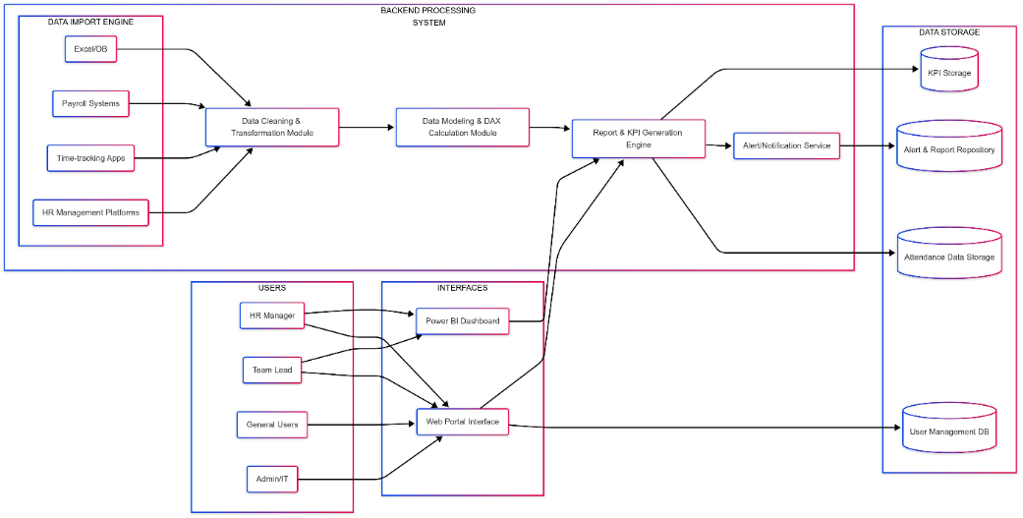

*Figure 5.1 Data Flow Diagram*

A system architecture for an HR data processing system, integrating multiple components for efficient data management. The Data Import Engine gathers information from sources like Excel/DB, payroll systems, time-tracking apps, and HR management platforms. This data flows into the Backend Processing System, where it undergoes cleaning and transformation before being processed through a data modelling and DAX calculation module. The system then generates reports and KPIs, with an alert/notification service providing updates. The processed data is stored in various repositories, including KPI Storage, Alert & Report Repository, Attendance Data Storage, and User Management DB. Different users such as HR managers, team leads, general users, and IT admins interact with the system via a Power BI Dashboard and a Web Portal Interface, enabling them to access insights and make informed decisions. This architecture optimizes HR data handling, reporting, and overall efficiency.

### UML DIAGRAMS

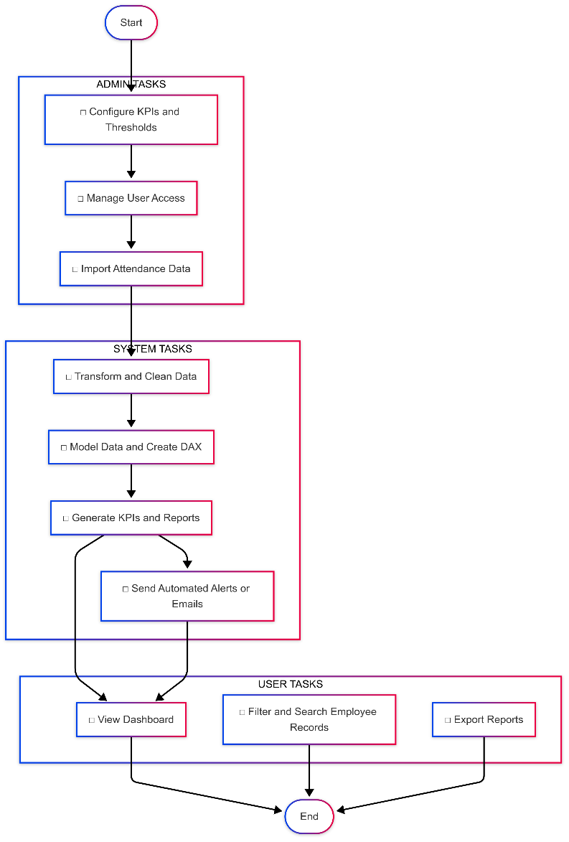

*Figure 5.2 Uml Diagram*

Unified Modeling Language (UML) diagrams serve as visual tools utilized to conceptualize, define, construct, and document various aspects of a system's architecture. Developed under the guidance of the Object Management Group (OMG), UML establishes a standardized method for representing diverse elements within software systems. By employing UML diagrams, stakeholders involved in software development endeavors can enhance communication and comprehension, fostering collaboration and synergy among team members.

Within the realm of software development, UML diagrams encompass a range of types, each tailored to address specific facets of the development lifecycle. For instance, class diagrams delineate the structural composition of a system by showcasing classes, attributes, methods, and their interrelationships. Meanwhile, sequence diagrams illustrate the chronological interactions between objects or components over time.

The utilization of UML diagrams yields manifold advantages throughout the software development continuum. Firstly, they serve as foundational blueprints, enabling developers to visually conceptualize and comprehend the architecture and behavior of the system prior to commencing implementation. Moreover, UML diagrams facilitate seamless communication among stakeholders of varying technical proficiencies, providing a universal visual language that fosters mutual understanding. Additionally, UML diagrams can be leveraged for code generation, expediting development processes while minimizing the incidence of errors, thereby enhancing efficiency and productivity.

In essence, UML diagrams occupy a pivotal role within the domain of software engineering, empowering stakeholders to undertake thorough analysis, design, and documentation of software systems. By furnishing a standardized notation for articulating system requirements, structure, and behavior, UML diagrams ensure clarity, coherence, and precision across the software development lifecycle.

#### GOALS

The Primary goals in the design of the UML are as follows:

* Provide a visual representation of the system's architecture and structure.
* Illustrate the relationships and interactions between different components of the system.
* Aid in understanding and communicating complex ideas and concepts among stakeholders.
* Facilitate comprehensive system analysis, design, and documentation.
* Serve as a blueprint for software development, guiding implementation and ensuring consistency.

### User Case Diagram

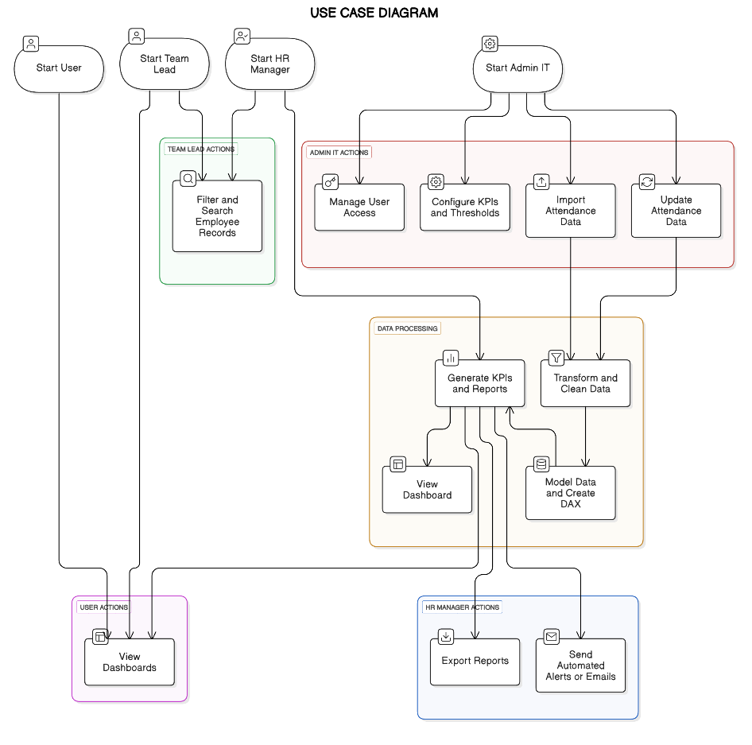

*Figure 5.3 User Case Diagram*

A use case diagram representing different user roles and their interactions with an HR data processing system. It includes Admin IT Actions (managing user access, configuring KPIs, and handling attendance data), Team Lead Actions (filtering and searching employee records), HR Manager Actions (exporting reports and sending automated alerts), User Actions (viewing dashboards), and Data Processing Tasks (transforming data, modelling it with DAX, generating KPIs, and viewing dashboards). Each role performs specific tasks that contribute to efficient HR data management and reporting.

### Class Diagram

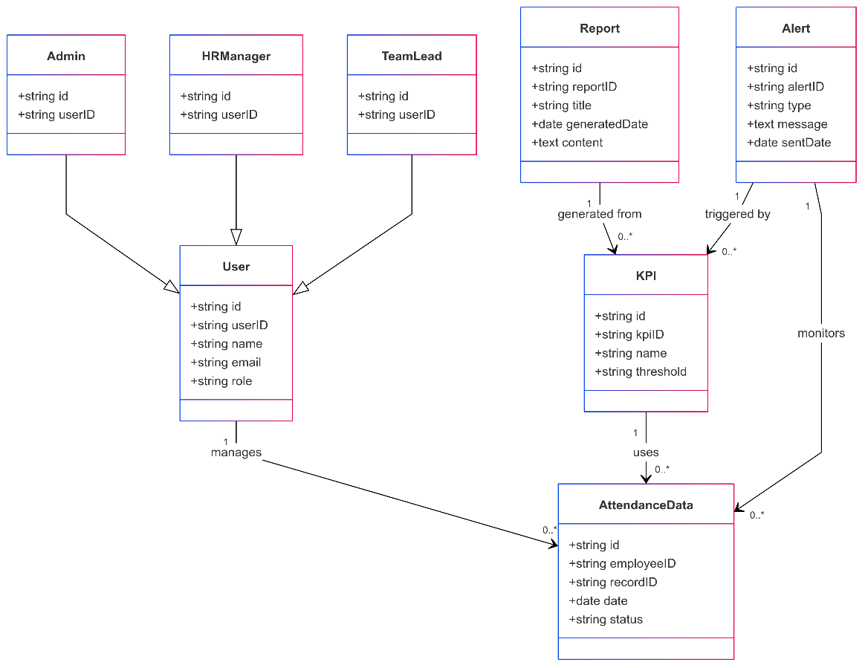

*Figure 5.4 Class Diagram*

A class diagram representing the structure of an HR data management system, detailing various entities and their relationships. The User class serves as a central entity, associated with different roles such as Admin, HR Manager, and Team Lead, each identified by an ID and user ID. The system tracks Attendance Data, which is linked to KPIs (Key Performance Indicators) that are used for monitoring employee performance. Reports are generated from KPIs, while Alerts are triggered by KPI thresholds being met. The diagram illustrates how users manage attendance data, generate reports, and receive alerts, providing a structured approach to HR data handling.

### Sequence Diagram

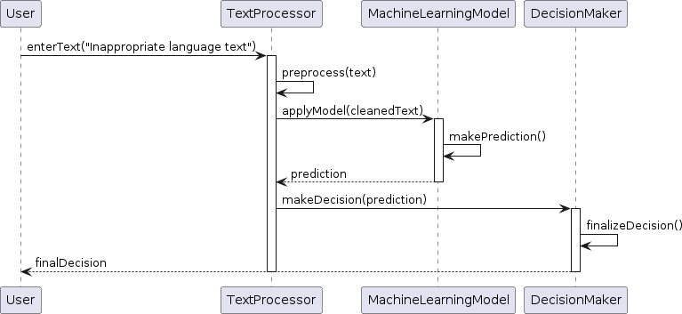

*Figure 5.5 Sequential Diagram*

A sequential diagram, also known as a sequence diagram, is a type of interaction diagram in Unified Modeling Language (UML) that illustrates the interactions between objects or components in a system over time. It displays the sequence of messages exchanged between these objects or components, showing the order in which they occur. Sequential diagrams are particularly useful for visualizing the dynamic behavior of a system, including the flow of control and data during the execution of a particular scenario or use case. They provide a detailed view of how objects collaborate to accomplish specific tasks or functionalities within the system.

### Collaboration Diagram



*Figure 5.6 Collaboration Diagram*

A collaboration diagram, also known as a communication diagram, is a type of interaction diagram in Unified Modeling Language (UML) that illustrates the interactions and relationships between objects or components within a system. Unlike sequence diagrams, which focus on the chronological order of messages, collaboration diagrams emphasize the structural organization of the system and the flow of communication between objects. They depict the objects as nodes and the communication links between them as labeled arrows, showing how objects collaborate to achieve specific functionalities or behaviors. Collaboration diagrams help visualize the relationships and interactions among objects, aiding in the understanding and design of the system's architecture.

# CHAPTER-6 IMPLEMENTATION

## IMPLEMENTATION

### Technology Description

#### Power BI

Power BI is a business intelligence tool used for data analysis, visualization, and reporting. It allows organizations to transform raw data into meaningful insights, making it ideal for HR analytics. This project utilizes Power BI to track employee attendance, monitor work-from-home (WFH) trends, and analyze leave patterns. The implementation focuses on Power Query for data transformation and DAX (Data Analysis Expressions) for advanced calculations.

#### Advantages of Power BI:

1. Data Visualization:

* Power BI transforms complex data into easily understandable visual representations, such as charts, graphs, and maps. This allows stakeholders to quick grasp key insights and trends.
* Interactive dashboards enable users to explore data dynamically, drilling down into specific details and gaining a deeper understanding of project performance.

1. Real-time Data Monitoring:

* Power BI facilitates real-time data updates, providing project managers with up-to-the-minute information on project progress, resource allocation, and potential risks.
* This enables proactive decision-making and allows for timely adjustments to keep projects on track.

1. Scalability and Flexibility:

* Power BI can handle large datasets and complex analytics scenarios, making it suitable for projects of all sizes.
* It's cloud-based architecture adds to its flexibility.
* Power BI integrates with Excel, databases, cloud services, and social media platforms.

### Techniques Used

Data Acquisition and Storage

1. Data Import from Excel

* Method: Importing structured employee attendance data from multiple Excel sheets.
* Purpose: Initial data ingestion and loading into the Power BI environment

1. Data Storage in Power BI Data Model

• Method: Loading transformed and cleaned data into Power BI's in-memory data model.

• Purpose: Facilitating efficient data analysis, calculations, and visualization.

Data Transformation and Cleaning

1. Data Consolidation

• Method: Combining data from separate Excel sheets into a single, unified dataset.

• Purpose: Creating a comprehensive dataset for analysis.

1. Data Reshaping

• Method: Transforming wide-format data into long-format data .

• Purpose: Restructuring data for time-series analysis and efficient calculations.

1. Data Cleaning

• Method: Using the first row of data as column headers.

* Purpose: Ensuring accurate column naming for data manipulation

1. Creating Reusable Templates (Power Query)

* Method: Developing a set of transformation steps that can be consistently applied to multiple datasets.
* Purpose: Automating and standardizing data transformation processes.

1. Creating parameters

* Method: Implementing dynamic filters within Power Query.
* Purpose: Enhancing data handling flexibility and enabling interactive data exploration.

1. Creating custom functions

* Method: Converting transformation steps into reusable functions within Power Query.
* Purpose: Promoting code reusability and simplifying data transformation processes.

DAX Calculations

Data Analysis Expressions (DAX) served as the computational engine for deriving crucial HR insights. We began by establishing a "Measures" table to organize our calculations, ensuring a clean and manageable data model.

#### Advantages of DAX Calculations:

1. To quantify overall workforce presence, we calculated "Total Working Days," excluding holidays and weekends, providing a baseline for attendance metrics. Recognizing the nuances of remote work, "WFH Count" was computed, assigning numerical values to both full and half work-from-home entries, allowing us to accurately track remote participation.
2. Similarly, "SL Count" quantified sick leave, distinguishing between full and half-day absences. "Present Days" then combined physical presence with remote contributions, offering a holistic view of employee attendance.
3. "Total Employee Count" gave us a headcount, essential for normalizing and contextualizing other metrics. In essence, DAX empowered us to transform raw attendance data into actionable insights, enabling HR to make data-driven decisions regarding employee presence, remote work, and leave patterns.

Dashboard Development

The dashboard development phase of this project relied heavily on the strategic application of Power BI's visualization capabilities to translate calculated DAX measures into actionable insights. We began by utilizing card visuals to display key performance indicators (KPIs).

#### Advantages of Dashboard Development:

The overall **dashboard design** focused on creating a user-friendly interface, arranging visualizations logically to guide the user through the data and facilitate quick comprehension. Finally, meticulous **formatting** was applied to enhance clarity and readability, ensuring that the dashboard effectively communicated key insights to HR professionals. Through these techniques, the dashboard served as a powerful tool for data-driven decision-making, providing a comprehensive and interactive view of employee attendance and leave patterns.

### Source code

#### DAX Code

DAX was used to create HR metrics such as attendance percentage and absenteeism trends. Below are the measures used:

1. **Calculating Total Working Days with DAX:**

This calculation is essential for determining metrics like attendance percentage, sick leave percentage, and WFH percentage. The DAX formula you provided calculates the total number of working days by excluding holidays and weekends from the total number of days in the dataset.

Total Working Days =

VAR TotalDays = COUNT('finalData'[Value])

VAR Holidays = CALCULATE(COUNT('finalData'[Value]), 'finalData'[Value] IN {"WO", "HO"})

RETURN TotalDays - Holidays

1. **Calculating WFH Count with DAX:**

We need to assign numerical values to WFH and HWFH entries to incorporate them into our present-day calculation. We'll create a calculated column named "WFH Count" in the finalData table. The following DAX expression creates the "WFH Count" column.

WFH Count = SWITCH( TRUE(),

'finalData'[Value] = "WFH", 1,

'finalData'[Value] = "HWFH", 0.5, 0 )

Now, create a DAX measure to sum up the values in the "WFH Count" column:

WFH Count = SUM('finalData'[WFH Count])

1. **Calculating SL Count with DAX:**

We need to assign numerical values to SL and HSL entries to incorporate them into our Sick Leave calculation. We’ll create a column named “SL Count” in finalData table. This following DAX expression creates the “SL Count” column.

SL Count = SWITCH( TRUE(),

‘finalData’[Value] = ”SL”, 1,

‘finalData’[Value] = “HSL”, 0.5,0) .

Now, create a DAX measure to sum up the values in the "WFH Count" column:

SL Count = SUM('finalData'[SL Count])

1. **Calculating Present Days:**

Create a DAX measure to calculate the total present day, including WFH and HWFH:

Present Days =

VAR PresentDays = CALCULATE (COUNT(‘finalData’[Value] = “P”)

RETURN PresentDays + [WFH Count].

1. **Calculating Present percentage:**

Finally, create a DAX measure to calculate the present percentage:

Present % = DIVIDE([Present Days], 'Measure Table'[Total Working Days], 0).

1. **Calculating SL percentage:**

Finally, create a DAX measure to calculate the Sick Leave percentage:

SL % = DIVIDE([SL Count], 'Measure Table'[Total Working Days], 0).

1. **Calculating WFH Percentage:**

Finally, create a DAX measure to calculate the WFH percentage:

WFH % = DIVIDE([WFH Count], 'Measure Table'[Present Days], 0).

1. **Creating Month Column:**

To facilitate future analysis and reporting, it's beneficial to have a dedicated month column in your finalData table. This allows for easy filtering, grouping, and aggregation of data by month. The following DAX expression creates a new column named "Month" in the finalData table.

Month = STARTOFMONTH ('finalData'[Date]).

1. **Creating Total Employee Count:**

The following DAX expression creates a measure named "Total Employee Count":

Total Employee Count = DISTINCTCOUNT('finalData'[Employee_Code]).

# CHAPTER-7 TESTING

## TESTING

### Introduction to Testing

Testing is a procedure that identifies program errors. It is the primary quality metric used in software development. During testing, the program is run under a set of conditions known as test cases, and the output is analyzed to see if it is operating as expected. The process of executing software to validate its functionality and correctness is known as software testing.Theprocess of running a program to identify an error. An excellent test case has a high likelihood ofdiscovering an as-yet-undiscovered fault. A successful test reveals a previously unknown mistake. Software testing is typically done for two reasons:

* + - Detection of flaws
    - Estimation of reliability

#### Types of Testing

➔ Functionality Testing :

* + - Metric Accuracy: Verify that the "SL Count", "WFH Count", and "Employee Count" are accurately calculated from the underlying data.
    - Data Filtering: Test the date slicers to ensure they correctly filter all visuals on the dash-

board.

* + - Employee Filtering: Test the employee table to ensure that selecting an employee correctly filters the detailed employee attendance table.
    - Total Row Verification: Ensure that the "Total" row in the employee summary table accurately aggregates the data for all employees.

➔ Performance Testing:

* + - Data Refresh Performance: Measure the time it takes to refresh the dashboard with updated data from the data source. Evaluate the impact of data volume on refresh performance.
    - Loading Time: Measure the time it takes for the dashboard to load in Power BI Desktop and the Power BI Service. Assess the dashboard's responsiveness when interacting with slicers and filters.

➔ Accuracy Testing:

* + - Data Table Accuracy: Verify that the employee summary table shows accurate data for each employee. Verify that the detailed employee table shows the correct attendance codes for each employee on each date.
    - Error Analysis: Identify any common errors and analyze their causes.

➔ Data Validation Testing:

* + - Data Source Integrity: Confirm that the data source contains accurate and up-to-date attendance records. Verify that the data types and formats are consistent with the dashboard's requirements.
    - Calculation Verification: Manually calculating key metrics (e.g., present percentage, sick leave percentage) for a sample of employees and compare them with the dashboard's results.
    - Trend Analysis Accuracy: Verify that the trends displayed in charts align with the underlying data.
    - Confirm that the day-of-week trends are accurately represented in the respective tables.

➔ Regression Testing:

* + - Data Updates: After updating the data source, re-run all test cases to ensure that existing functionalities are not affected.
    - Dashboard Modifications: After making any changes to the dashboard, re-run all test cases to ensure that the changes do not introduce new issues.
    - Power BI Updates: After Power BI desktop or Power BI service updates, rerun the test cases to verify the dashboard still functions as intended.

➔ Usability Testing:

* + - Navigation: Assess the ease of navigation between different sections of the dashboard. Evaluate the clarity and intuitiveness of the dashboard's layout.
    - Interaction: Test the usability of slicers, filters, and other interactive elements. Evaluate

the clarity of tooltips and other informational elements.

* + - Visual Clarity: Assess the clarity and readability of the visualizations. Evaluate the use

of colors, fonts, and other design elements.

* + - Accessibility: Ensure that the system is accessible to users with different levels of experience and abilities.

**Test Results**

All the test cases mentioned above passed successfully. No defects encountered.

### Test Cases

Test cases can be divided in to two types. First one is Positive test cases and second one are negative test cases. The positive test cases are conducted by the developer and the intention is to get the output. The negative test cases are conducted by the developer and the intention is notto get the output.

**TEST CASES :**

|  |  |  |  |  |
| --- | --- | --- | --- | --- |
| **Test Case ID** | **Description** | **Test steps** | **Expected Output** | **Result** |
| UT-001 | Test total Employee Count Card | 1. Open Power BI desktop.  2. Create a card visual.  3. Drag the "Employee Count" measure into the card | The card displays the correct total employee count (74). | Success |
| UT-002 | Test Present % Measure | 1. Create a card visual.  2. Drag the "PRESENT %" measure into the card.  3. Verify against the "Total" row in the employee table.. | The card displays the correct present percentage (91.83%). | Success |
| UT-003 | Test SL % Measure | 1. Create a card visual.  2. Drag the "SL %" measure into the card.  3. Verify against the "Total" row in the employee table. | The card displays the correct sick leave percentage (1.10%). | Success |
| UT-004 | Test Date Slicer Filtering (April 2022) | 1. Add a date slicer.  2. Select "Apr 22".  3. Observe the "PRESENT % by Date" chart and other visuals. | All visuals update correctly to reflect data for April 2022. | Success |
| UT-005 | Test Dashboard Loading Time | 1. Open the dashboard in the Power BI Service (or Desktop).  2. Measure the time it takes for the dashboard to load completely. | The dashboard loads within an acceptable timeframe. | Under 5 seconds |
| UT-006 | Test Slicer Usability | 1. Interact with the date slicer.  2. Observe how easy it is to select different date ranges. | The slicer is easy to use and provides clear visual feedback. | Success |

# CHAPTER-8 RESULTS

# &

# DISCUSSIONS

### Screenshots:

*Figure 8.1 Final Output*

### Results and Discussions

### Results:

This Power BI attendance dashboard presents an analysis of employee attendance data for the period of April to June 2022, as visualized in the provided Power BI dashboard snapshot. The dashboard provides key metrics, trend analysis, and detailed employee attendance information, enabling HR professionals to gain insights into attendance patterns, enhance overall organizational efficiency and make informed decisions.

* **Overall High Attendance:** The overall percentage of 91.83% suggests a generally healthy attendance culture. Attendance patterns vary by day of the week, with higher present percentages on Mondays and Tuesdays and higher work from home on Fridays.
* **Growing WFH Trend:** The increasing WFH percentage indicates a growing adoption of remote work, particularly on Fridays.
* **Potential Attendance Issues:** Ayanna Atkins and Ana Little require further investigation due to low presence and higher sick leave.
* **Day-of-Week Patterns:** Attendance is highest mid-week and lowest on Fridays, suggesting potential end-of-week fatigue or a preference for long weekends.
* **Sick Leave Fluctuations:** The overall sick leave percentage is low, suggesting either good employee health or potential underreporting. The fluctuations in sick leave percentage may indicate seasonal illnesses or other factors requiring further analysis.

### Recommendations:

These are the recommendations for HR, for Further analysis and investigation into specific trends and patterns can lead to more targeted interventions and improvements.

* **Investigate Employee-Specific Issues:** Conduct deeper analysis into the attendance and leave patterns of employees like Ayanna Atkins and Ana Little.
* **Formalize WFH Policies:** Consider formalizing remote work policies to accommodate the growing WFH trend, especially on Fridays.
* **Address End-of-Week Attendance:** Investigate the reasons for lower attendance on Fridays and consider implementing strategies to improve it.
* **Monitor Sick Leave Trends:** Continue to monitor sick leave trends and investigate potential causes for fluctuations.
* **Gather Employee Feedback:** Conduct surveys or focus groups to gather employee feedback on attendance policies, WFH arrangements, and overall well-being.

### 

# CHAPTER – 9 CONCLUSION

**&**

# FUTURE ENHANCEMENTS

## CONCLUSION & FUTURE ENHANCEMENTS

* 1. **CONCLUSION**

The study of this project successfully leveraged a combination of data transformation, calculation, and visualization techniques to unlock valuable HR insights from employee attendance data. The data acquisition phase, centered on **importing data from Excel**, provided the raw material for analysis. **Power Query** proved instrumental in the data transformation stage, where techniques like **unpivoting columns**, **removing errors**, and **creating reusable templates** ensured data cleanliness and consistency. The **DAX calculations**, including measures for "Present %," "SL %," and "WFH %," provided the analytical foundation for understanding attendance patterns and leave trends. The **Power BI dashboard**, featuring **card visuals**, **table visuals**, **clustered column charts**, and **slicers**, effectively translated these calculations into a user-friendly and interactive interface. The strategic **dashboard design** and meticulous **formatting** ensured that key HR metrics were presented clearly and concisely. Ultimately, this project demonstrated the power of data analytics in enhancing HR decision-making, providing a robust framework for continuous monitoring and improvement of employee attendance and leave management.

## FUTURE ENHANCEMENT

The potential for enhancing this study lies in the implementation of several key improvements, which would significantly strengthen its findings. Firstly, integrating **live email alerts** via Power Automate would enable proactive monitoring of critical HR metrics, triggering notifications for anomalies like excessive sick leave or low attendance. Secondly, transitioning to **continuous data streaming** from HRIS or attendance systems would provide real-time insights, eliminating manual data refreshes and ensuring up-to-date information. Incorporating **predictive analytics** through machine learning models would allow for forecasting attendance trends and potential attrition, facilitating proactive HR planning. Additionally, **sentiment analysis of leave requests** could provide valuable insights into employee well-being and stress levels. Integrating **employee performance data** would offer a holistic view of workforce dynamics, revealing correlations between attendance and performance. Optimizing the dashboard for **mobile accessibility** would enhance usability and enable on-the-go monitoring. Automating **report generation and distribution** would streamline reporting processes and ensure timely information dissemination.

Implementing **granular access control** would enhance data security and compliance. Finally, incorporating **interactive "what-if" analysis** would empower HR professionals to simulate the impact of policy changes and strategic decisions, fostering data-driven planning.

# CHAPTER-10 REFERENCES

### References

1. Kuriakose, A. “HR Analytics - Empowering Organization.” *International Journal of Research in Engineering, Science and Management* 3, no. 12 (2020): 1-5.
2. Mohammed, A. Q. “HR Analytics: A Modern Tool in HR.” *Journal of Management and Science* 10, no. 1 (2020): 45-58.
3. Bangura, S. “Effects of HR Analytics on HRM Practices.” *International Journal of Human Resource Studies* 11, no. 1 (2021): 20-35.
4. Zebua, D. K. “The Role of HR Analytics in Enhancing Organizational Performance.” *Journal of Industrial Engineering and Management Systems* 13, no. 2 (2020): 180-195.
5. Xin, J. L. J., and Mahadi, N. “HR Analytics for Data-Driven Employee Attrition Management.” *Journal of Information and Communication Technology* 19, no. 3 (2020): 250-265.
6. Khadilkar, N., and Joshi, D. “Predictive Modelling on Employability of Applicants and Job-Hopping.” *International Journal of Advanced Research in Computer Science* 11, no. 4 (2020): 80-92.
7. Zhao, Y., and Hryniewicki, M. K. “Employee Turnover Prediction.” *Proceedings of the 2021 International Conference on Machine Learning and Data Engineering (MLDE)* (2021): 110-118.
8. Mishra, S. N., and Lama, D. R. “A Decision-Making Model for Human Resource.” *International Journal of Business Analytics* 8, no. 2 (2021): 150-165.
9. Tambde, A., and Motwani, D. “Employee Churn Rate Prediction and Performance.” *Journal of Artificial Intelligence and Data Mining* 9, no. 1 (2021): 70-85.
10. Davenport, T. H., Harris, J. G., and Shapiro, A. L. “Competing on Talent Analytics.” *Harvard Business Review* 88, no. 10 (2010): 52-58.
11. Fitz-enz, J., and Mattox, J. “Predictive Analytics for Human Resources.” *John Wiley & Sons*, 2014.
12. Edwards, M. R., and Edwards, K. “Predictive HR Analytics: Mastering the HR Metric.” *Kogan Page Publishers*, 2016.



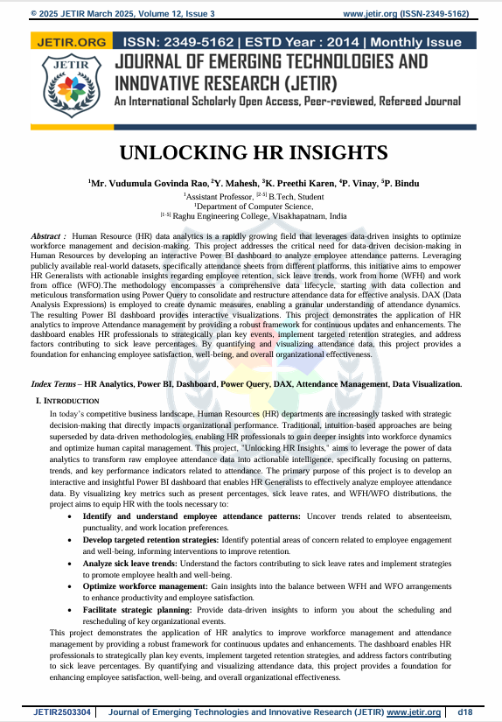

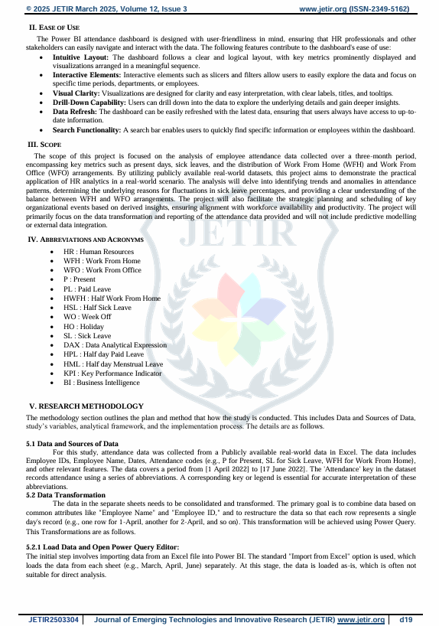

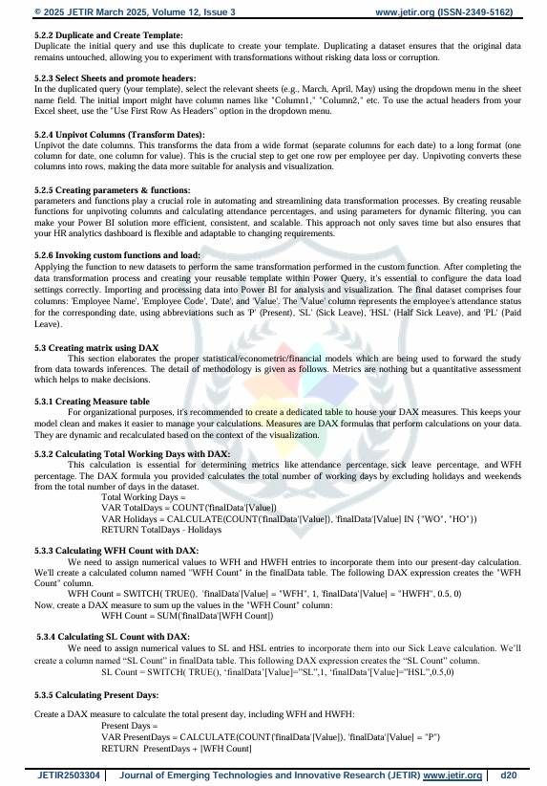

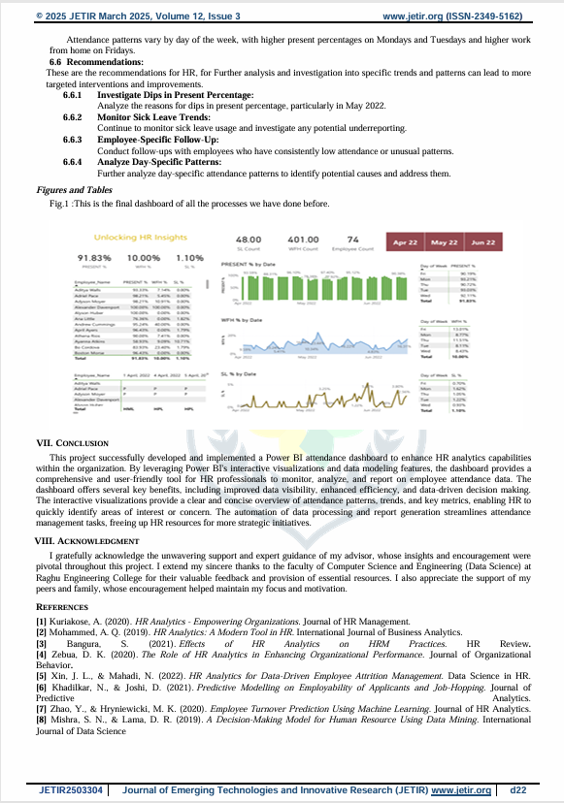



# CHAPTER-11 INTERNSHIP CERTIFICATES

